D.K.T.E. Society’s Textile and Engineering Institute, Ichalkaranji. (An Autonomous Institute, Affiliated to Shivaji University, Kolhapur)

Department of Information Technology 2019-2020

# Project-II Report On

“Automation of Stock Monitoring System”

# Under the Guidance Of

Prof. S. D. Rane

# Submitted By:

1. Mr. Suraj Sarjerao Jadhav 181IT2607086
2. Mr. Swapnil Vishnu Dake 181IT2107081
3. Mr. Nikhil Narayan Dhoble 181IT2607082
4. Mr. Shubham Rajendra Sontakke 181IT2607092
5. Mr. Sushant Uttam Godbharle 181IT2607084

|  |  |  |
| --- | --- | --- |
| Prof. S. D. Rane | Prof. (Dr).D.V. Kodavde | Prof.(Dr).P.V.Kadole |
| **(Project Guide)** | **(H.O.D)** | **(Director)** |



# YEAR 2019-2020

DEPARTMENT OF INFORMATION TECHNOLOGY

**CERTIFICATE**

This is to certify that the project report entitles “Automation of Stock Monitoring System ” is record of project work carried out in this college by,

1. Mr. Suraj Sarjerao Jadhav ( 181IT2607086 )
2. Mr. Swapnil Vishnu Dake ( 181IT2107081 )
3. Mr. Nikhil Narayan Dhoble ( 181IT2607082 )
4. Mr. Shubham Rajendra Sontakke ( 181IT2607092 )
5. Mr. Sushant Uttam Godbharle ( 181IT2607084 )

in fulfillment of the requirement for degree of BACHELOR OF TECHNOLOGY in INFORMATION TECHNOLOGY of SHIVAJI UNIVERSITY, KOLHAPUR. This project report

is record of their own work carried out under my supervision and guidance during academic year 2019-2020.

Prof. S. D. Rane Prof. (Dr.) D. V. Kodavde

## [Project Guide] [Head of the Department]

Prof. (Dr.) P.V. KADOLE

## [Director]

**DECLARATION**

We the undersigned students of B.Tech Information Technology declare that, the field work report entitled “Automation of Stock Monitoring System” written and submitted under the guidance of Prof. S. D. Rane is our original work. The empirical findings in this report are based on the data collected by us. The matter assimilated in this report is not reproduction from any readymade report.

Date:

Place: Ichalkaranji.

**Members** Signature

1. Mr. Suraj S Jadhav ( 181IT2607086 )
2. Mr. Swapnil V Dake ( 181IT2107081 )
3. Mr. Nikhil N Dhoble ( 181IT2607082 )
4. Mr. Shubham R Sontakke ( 181IT2607092 )
5. Mr. Sushant U Godbharle ( 181IT2607084 )

**ACKNOWLEDGMENT**

With great pleasure we wish to express our deep sense of gratitude to Prof .S. D. Rane for his valuable guidelines, support and encouragement in completion of project report.

Also, we would like to take opportunity to thank our head of department Dr. D. V. Kodavde for his co-operation in preparing this project report.

We feel gratified to record our cordial thank to other staff members of Information Technology department for their support, help and assistance which they extended as and when required.

Thank you,

1. Mr. Suraj Sarjerao Jadhav 181IT2607086
2. Mr. Swapnil Vishnu Dake 181IT2107081
3. Mr. Nikhil Narayan Dhoble 181IT2607082
4. Mr. Shubham Rajendra Sontakke 181IT2607092
5. Mr. Sushant Uttam Godbharle 181IT2607084

**ABSTRACT**

The objective of this system is to use to the Stock Management in a Warehouse to converting the warehouse into a smart warehouse. It include Data analysis like, type of stock their weight its total and also rate.Inventory management is the supervision of supply, storage and accessibility of items.

The project Automation of Stock Monitoring System   is designed to handle the warehousing stocks and this software application maintain the records that include good stock going in and out and other related issues.

Features included in it Automated ordering of grocery stock and analysis of all data without using manual work. This system generates overall day to day report without any error automatically.

Whenever stock enters into the stock storage room this system done all the work manually without any man power.Automatic stock monitoring  systems are used by a business to monitor how much stock they have at any instant. Stock control software allows a business to work efficiently by making sure that there is a sufficient stock of goods available to meet the orders that are received.

**INDEX**

**CONTENTS PAGE**

1. **INTRODUCTION**
   1. Problem Statement
   2. Need of the project with motivating example
   3. Objective of Project
   4. Limitations and Scope
   5. Timeline for project
   6. Cost of project

# BACKGROUND STUDY AND LITERATURE REVIEW

* 1. Technology review
  2. Literature review

# REQUIREMENT ANALYSIS

* 1. Functional requirements
     1. User Interface requirements
     2. Hardware interface requirements
     3. Communication protocol requirements

3.1.4. Modular/ Component Requirements

* 1. System Requirements
     1. Hardware Requirements
     2. Operating System Requirements
     3. Application or Web server requirements
     4. Storage requirement
     5. Tools and Technologies Requirements

# SYSTEM DESIGN

* 1. Architecture Diagram
  2. Use case Diagram
  3. Data Flow Diagram
  4. Sequence diagram
  5. Class Diagram

# IMPLEMENTATION

1. **SOFTWARE TESTING**
   1. Unit test cases generation and its testing reports
   2. Integration test cases generation and its testing reports
   3. System test cases generation and its testing reports

# OUTPUT SCREEN

1. **PERFORMANCE ANALYSIS**
2. **APPLICATION**
3. **CONCLUSION:**

## GUIDE TO ACCESS APPLICATION AND USER MANUAL

## ETHICS

1. **REFERENCE**
2. **INTRODUCTION**
   1. **Problem Statement**

The project Stock Monitoring System is designed to handle the warehousing stocks and this system maintain the records that include good stock going in and out and other related issues

* 1. **Need of the project with motivating example**

1. To reduce the lots of manual work.

2. Maximize the scalability.

3. Decrease the human error and get accuracy in stock management.

4. To identify the right product and save their detailed data.

5. It also helps to prevents all the products from the different frauds.

## Objective of Project

1. To study in detail existing manual stock monitoring and need of automated stock monitoring to overcome existing problems in the system.
2. To prevents all the products from the different frauds.
3. The administrative controls over the warehouse and he has rights to perform modification
4. All the data is stored into the database so it helps to availability of any time.
5. Identification of the product and their accurate weight is automatically added in system.

## Limitations and Scope

* + 1. Existing System

In today’s system we requires many persons on the different departments like, to calculate the weight of stock, to write the detailed data about stock and many more manual work. The present system is based on manual technique and this project tends to automate the system so that maintaining the records of good stock, goods in and got out becomes easier than before.

* + 1. Limitations

Existing system has following limitation-

* + Peoples tends to make error in manual data entry.
  + Efficiency and accuracy is not expected.
  + Time consuming and slow processing.
    1. Scope

1. keeps the track of various products and level of the stock at various sectors of warehouse.
2. Platform for solving stock monitoring issues.
3. database availability of any time.
4. Identification of the product and their accurate weight is automatically

## Timeline for project

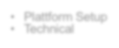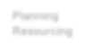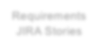

Planning Resourcing

Sprints / Kanban / Agile Development

* Plattform Setup
* Technical

Quality Assurance / Testing

Interim Infrastructure, API Services Definition

Launch

Beta App & Pilotierung

Launch

Data Privacy Security

UX / UI Design / Look & Feel

Long Term Infrastructure, API Services Integration

Mockups, Wireframes

QA / Testing / Documentation

Requirements JIRA Stories

Progress

Long-Term IT Systems Integration

Feb.

Jan.

Dec

Nov

Oct

Sept

End Aug

Start Aug

End July

* 1. **Cost of project:**

|  |  |  |  |
| --- | --- | --- | --- |
| Sr No. | **Equipment** | **Details** | Price(Rs) |
| 1. | Electricity | Consumed 40 units | 120 |
| 2. | Internet | 1000 GB | 2500 |
| 3. | Camera | 3.6 mm resolution | 8000 |
| 4. | Desktop computer | 4GB RAM and above  i3 processor | 11499 |

Estimated cost by considering other factors will be approx. **- Rs. 22119/-**

# BACKGROUND STUDY AND LITERATURE REVIEW

## Technology review

## Inventory Management software monitors inventory levels for optimal production and distribution of goods for wholesale or retail.Inventory management is the supervision of supply, storage and accessibility of items in order to ensure an adequate supply without excessive oversupply. Stock Management is often associated with understanding the different levels of demand on that inventory.

## The present system is based on manual technique and this project tends to

## automate the system so that maintaining the record of goods stock, goods in and goods

## out becomes easier than before. This technique should able to provide quick reading of maintenance.

## The system includes an automated system by using a camera. In this system, the Camera will be placed at the top of the door. If any product is passed from that door the server will be initiated and will capture the any product image. Stock management application by using an image processing algorithm will recognize product and if all product we were ordered that product came to the warehouse then SMS will be sent to the owner.

## Literature review

## We found some of the literature papers based on Stock Monitoring System that uses some technologies and devices that aims to this project. Some of the literatures are as follows-

2.2.1 **A literature review on inventory management in humanitarian supply**

**Chains** - In this paper, we present a review and analysis of studies that focus on humanitarian inventory planning and management. Specifically, we focus on

papers which develop policies and models to determine how much to stock, where to stock, and when to stock throughout the humanitarian supply chain.

# 2.2.2 A literature review on models of inventory management under uncertainty- This paper analyzes possible parameters of existing models of inventory control. An attempt is made to provide an up-to-date review of existing literature, concentrating on descriptions of the characteristics and types of inventory control models that have been developed.

# 2.2.3 Research paper on Inventory management system by International Research Journal of Engineering and Technology (IRJET) - The requirements from the shopkeeper to create backup inventory within limited time and in highaccuracy makes us to come up with automation solution by using desktop. At this time we think that this is the based solution. However it might need some improvement in the future based on the lesson learned so is the new requirement from the shopkeeper

# REQUIREMENT ANALYSIS

## Functional requirements

* + 1. User Interface requirements
       1. Admin should be able to register him/her on the application.
       2. Owner has add order, delete order authority.
       3. User should be capable to see old data any time.
       4. Search inventory, details of inventory should be provided.
       5. Scanned data is added automatically in database.
       6. It allows admin to generate details report.
       7. It allows admin to generate stock statement report.
       8. It allows any user to logout when he wants to come out from the system.
    2. Software interface requirements
       1. Python – it used for develop and deploy the frontend code.
       2. Windows os platform- to develop and run the System.
       3. Pycharm- To test the code.
       4. Cmd-To install the required packages
       5. Xampp- for storing database details.

## 3.2 System Requirements

* + 1. Hardware Requirements
       1. Machine with minimum 4 GB of RAM for developing environment and formation of the network.
    2. Operating System Requirements
       1. Windows operating system for installation of software and required framework.
    3. Application or Web server requirements
       1. Python application to execute the overall system.
       2. CMD to run the different commands.
    4. Tools and Technologies Requirements
       1. Pycharm-To install the numpy, np, cv2 etc. packages.
       2. Database: MySQL 5.0
       3. Server: Xampp

# SYSTEM DESIGN

* 1. Architecture Diagram

Following diagram shows the interaction between components and modules of the project.

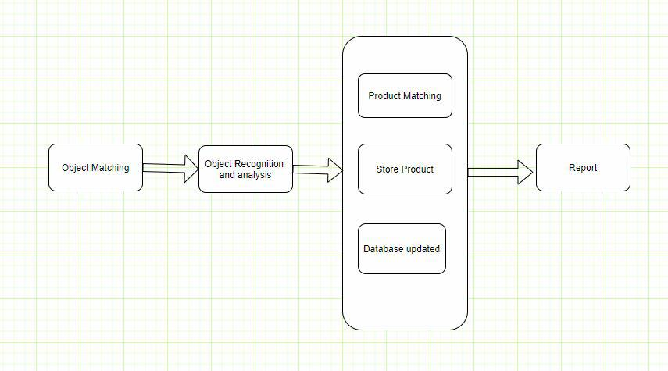

Fig 4.1 System Architecture Diagram

C

* + 1. **ALGORITHM DESCRIPTION OF EACH MODULE**

**Module 1: Image Recognition**

**Input:** Images of Product (JPG, JPEG).

**Output:** Image capture

**Description:** Capture the image of bag. Object detection is a computer technology related to computer vision and image processing that deals with detecting instances of semantic objects of a certain class in digital images.

**Module 2:** **Object matching**

**Input:** Product image (JPG, JPEG).

**Output:** Product Updation

**Description:** Match the new image of the object with the already stored the image in the database. If the image is matched then its return true. Product details is stored into database and database is updated. If product is not matched with stored image then its gives false alert.

**Module 3:** **Report Generation**

**Input:** Product Detail

**Output:** Report

**Description:** At the last stage system generated day to day report. This report includes details of product and their quantity. For more understanding this system gives availability in histogram, pie chart format.

* 1. Use Case Diagram

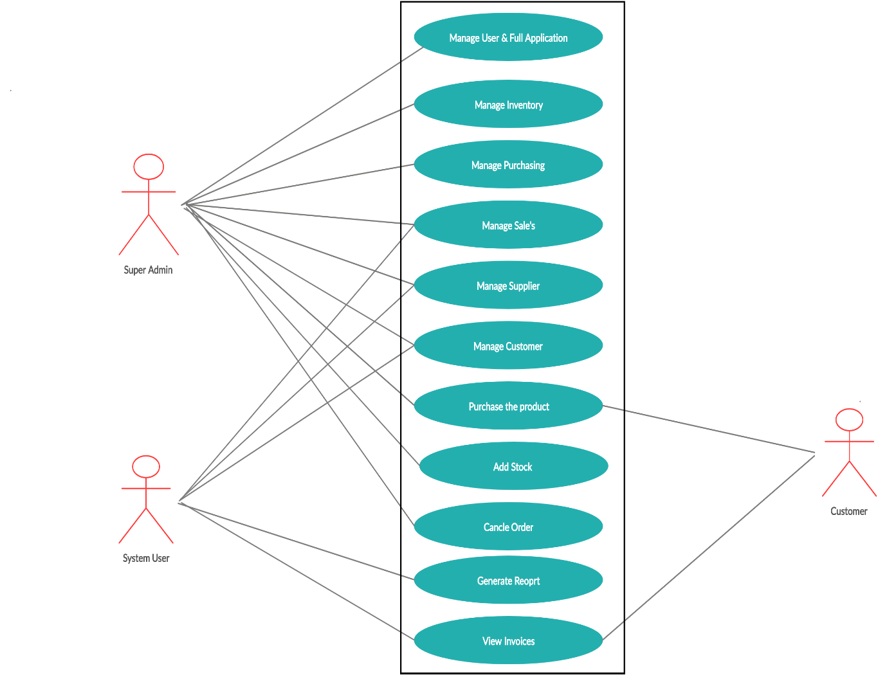

Fig 4.2 Use Case Diagram

As we see in above diagram our main functionalities are shown. These functionalities are used by admin to monitoring overall inventory System.

* 1. Data Flow Diagram-
     1. DFD level 0



Fig 4.4.1 Diagram of DFD Level 0

As shown in diagram firstly product is captured and according to details of the product it goes to all inventory system. Finally it store into database and report is generated.

* + 1. DFD level 1

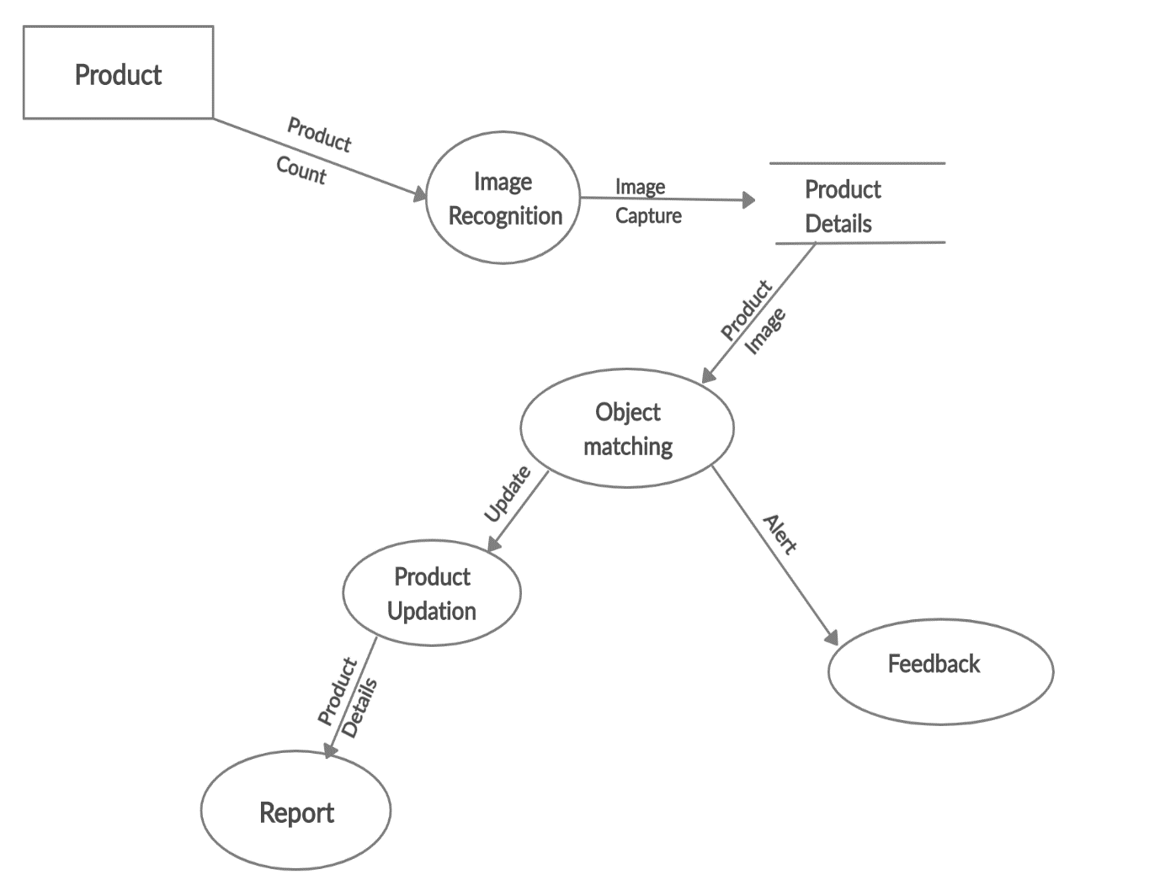

Fig 4.4.2 Diagram of DFD level 1

As shown in diagram the specific functionality of each module is given. The corresponding input and output is shown above of the arrow. The arrows are showing the flow of the system.

* 1. Sequence diagram

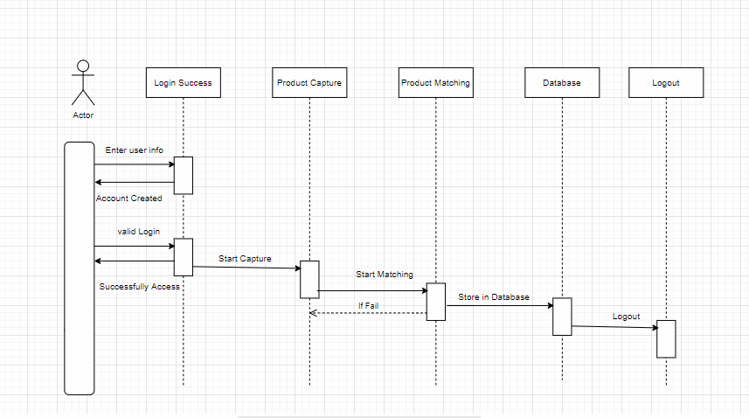

Fig 4.5 Sequence Diagram of System.

As we can see in diagram the sequence of several activities are shown, which are carried out in specific manner.

* 1. Class Diagram

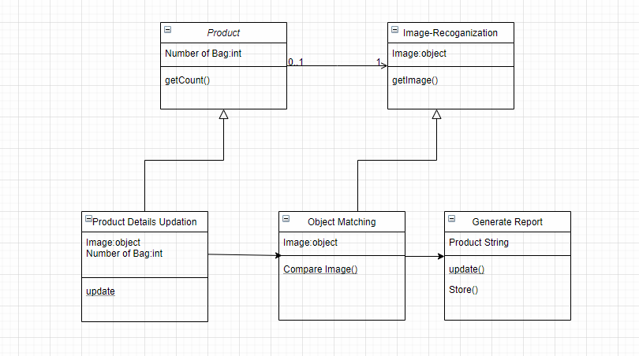

Fig 4.6 Class Diagram of Inventory System.

As we see in image we have mainly five classes consisting numerous functions to interact with inventory system.

## IMPLEMENTATION

**5.1.1 Environmental settings for running the module –**

* + 1. Install Python
    2. Install tkinter package
    3. Install cv2 package
    4. Install mysql

1. Run the Applications.

## 5.1.2 Installation of Pyhton

Python provides the basic infrastructure for installation of dependencies. Commands to install Python –

* + - 1. sudo apt-get update
      2. sudo apt-get install python3.6
      3. import cv2
      4. import numpy

## Installation of packages-

There are following packages are required to run the system.

1. Import tkinter-Tkinter is the standard GUI library for Python. Python when combined with Tkinter provides a fast and easy way to create GUI applications. Tkinter provides a powerful object-oriented interface to the Tk GUI toolkit.
2. Import cv2-OpenCV-Python is a library of Python bindings designed to solve computer vision problems. All the OpenCV array structures are converted to and from Numpy arrays. OpenCV-Python is a library of Python bindings designed to solve computer vision problems.
3. Import numpy- It provides fast and efficient operations on arrays of homogeneous data. Numpy extends python into a high-level language for manipulating numerical data, similar to MATLAB.
4. Import random- Python offers random module that can generate random numbers. These are pseudo-random number as the sequence of number generated depends on the seed.
5. Import time- The Python time module provides many ways of representing time in code, such as objects, numbers, and strings. It also provides functionality other than representing time.

## Editor for front end Development

We have used sublinetext editor for front end development in typescript. Python is an open-source programming language .Steps to install python-

sudo apt-get update

sudo apt-get install python3.6

import tkinter

After that we can write the code in editor and compile-

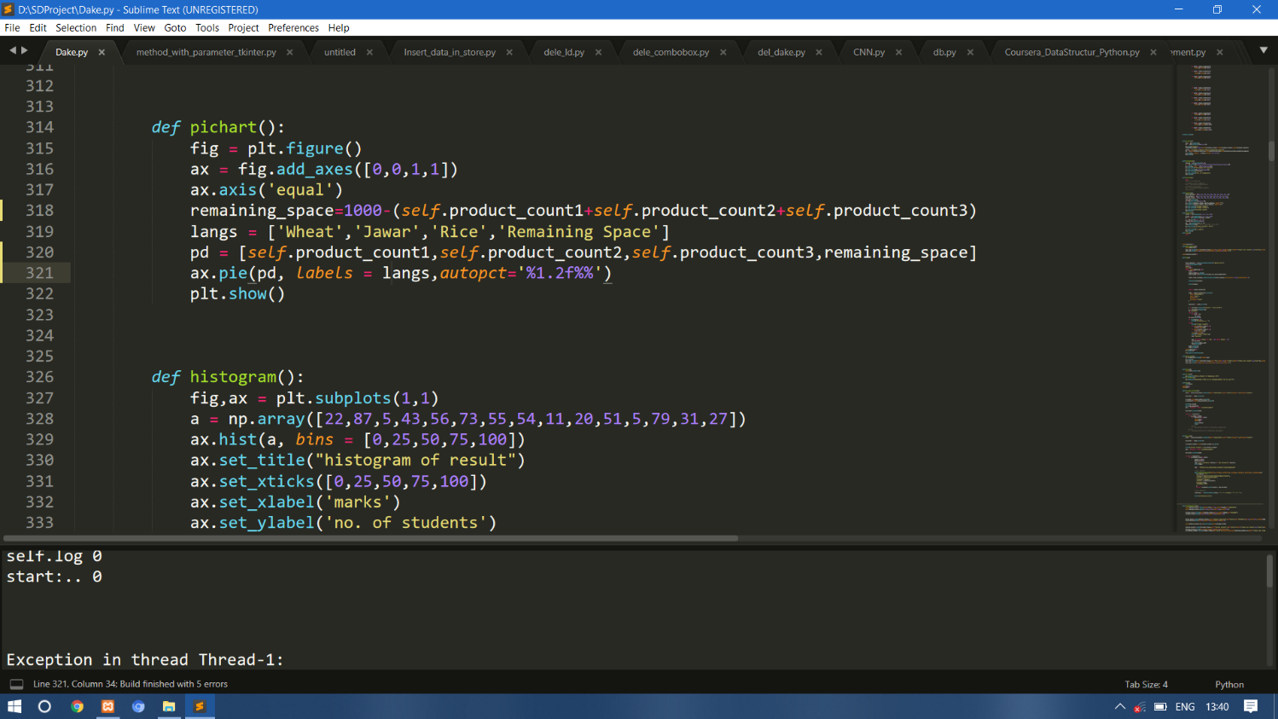

As we can see in image, for frontend development we have use python . tkinter package is required to graphical designing. This is the widely used for web development.

## SOFTWARE TESTING

* 1. **Unit test cases generation and its testing reports**
     1. Test cases for signup

|  |  |  |  |  |  |
| --- | --- | --- | --- | --- | --- |
| Test case No | Test case | Input | Expected Output | Actual Output | Status |
| 01 | Sign up | Name, Password, mobile no,  Otp. | Sign up successful | Sign up successful | Pass |

* + 1. Test cases for Login

|  |  |  |  |  |  |
| --- | --- | --- | --- | --- | --- |
| Test case No | Test case | Input | Expected Output | Actual Output | Status |
| 01 | User is already registered | Name, Password | Successful login | Successful login | Pass |
| 02 | User is not registered | Name, Password | Give error message. | Give error message . | Pass |

* + 1. Test cases for Product capture.

|  |  |  |  |  |  |
| --- | --- | --- | --- | --- | --- |
| Test case No | Test case | Input | Expected Output | Actual Output | Status |
| 01 | Product captured | product | It goes for next process. | It goes for next process. | Pass |
| 02 | Product is not captured | product | Invalid product | Invalid product | Pass |

* + 1. Test cases for object matching

|  |  |  |  |  |  |
| --- | --- | --- | --- | --- | --- |
| Test case No | Test case | Input | Expected Output | Actual Output | Status |
| 01 | Product image is matched. | Product | Product is valid and add into database successfully | Product is valid and add into database successfully | Pass |
| 02 | Product  image is  not matched. | product | Product is not valid. | Product is not valid. | pass |

**6.2 Integration test cases generation and its testing reports**

|  |  |  |  |  |  |
| --- | --- | --- | --- | --- | --- |
| Test case No | Test case | Input | Expected Output | Actual Output | Status |
| 01 | Login | Username  Password | Login  successful | Login  successful | Pass |
| 02 | Sign up | Name, Password, Otp. | Registration successful | Registration successful | Pass |
| 03 | Product capture | product | Goes to next process | Goes to next process | Pass |
| 04 | Product matching | product | Added to database. | Added to database. | pass |

* 1. **System test cases generation and its testing reports**

|  |  |  |  |  |  |
| --- | --- | --- | --- | --- | --- |
| Test case No | Test case | Input | Expected Output | Actual Output | Status |
| 01 | Able to  access the system | link on network | System access successfully | System access successfully | Pass |
| 02 | Creating account automatically by providing valid credential. | user name, password ,otp | Get account Successfully | Get account Successfully | pass |

**7.Output Screen**

Given below is the screenshot that shows, how actual system gives output throughout various steps.

1. **Product details -**

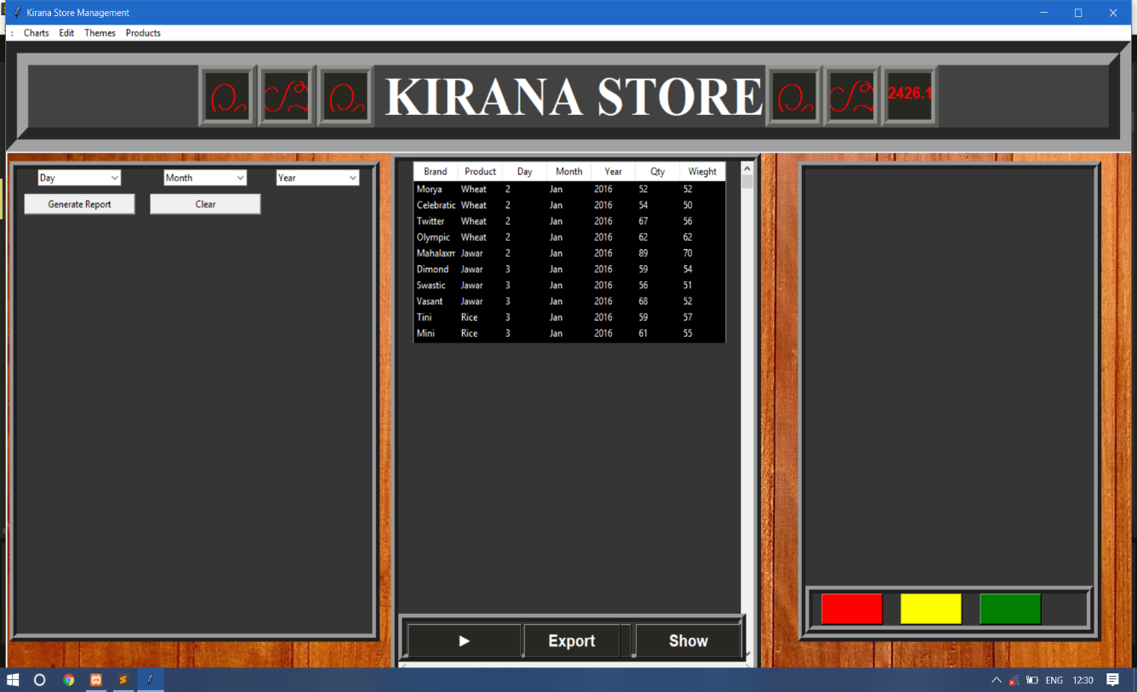

1. **Availability of product–**

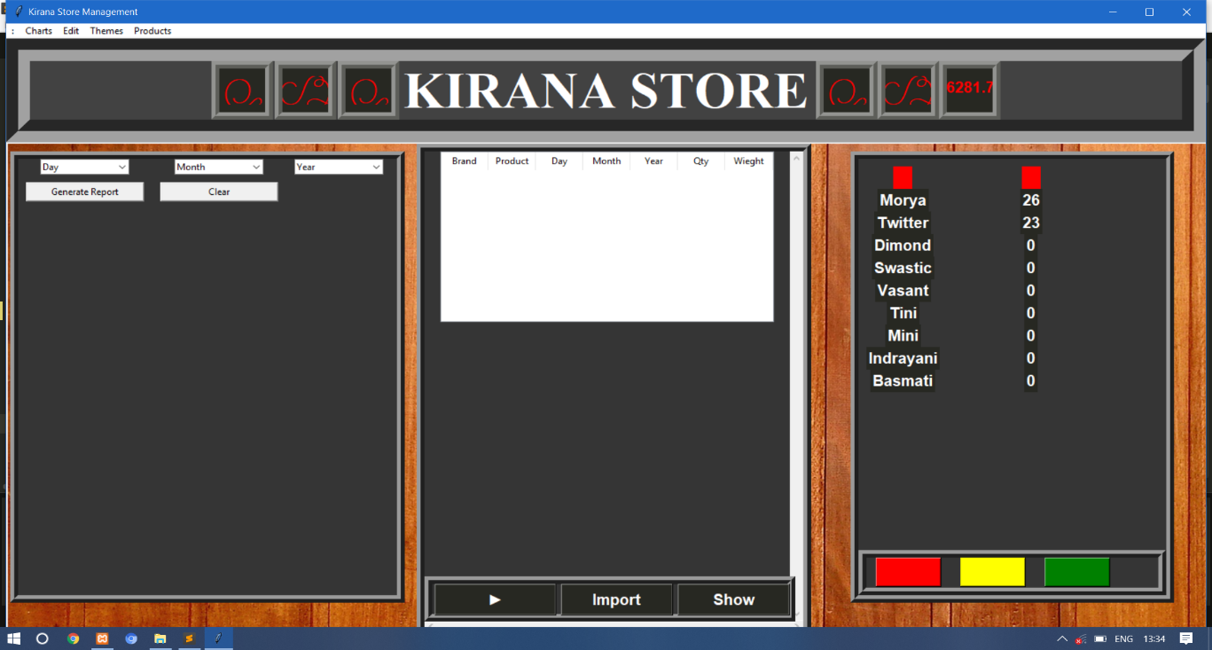

1. **Report-**

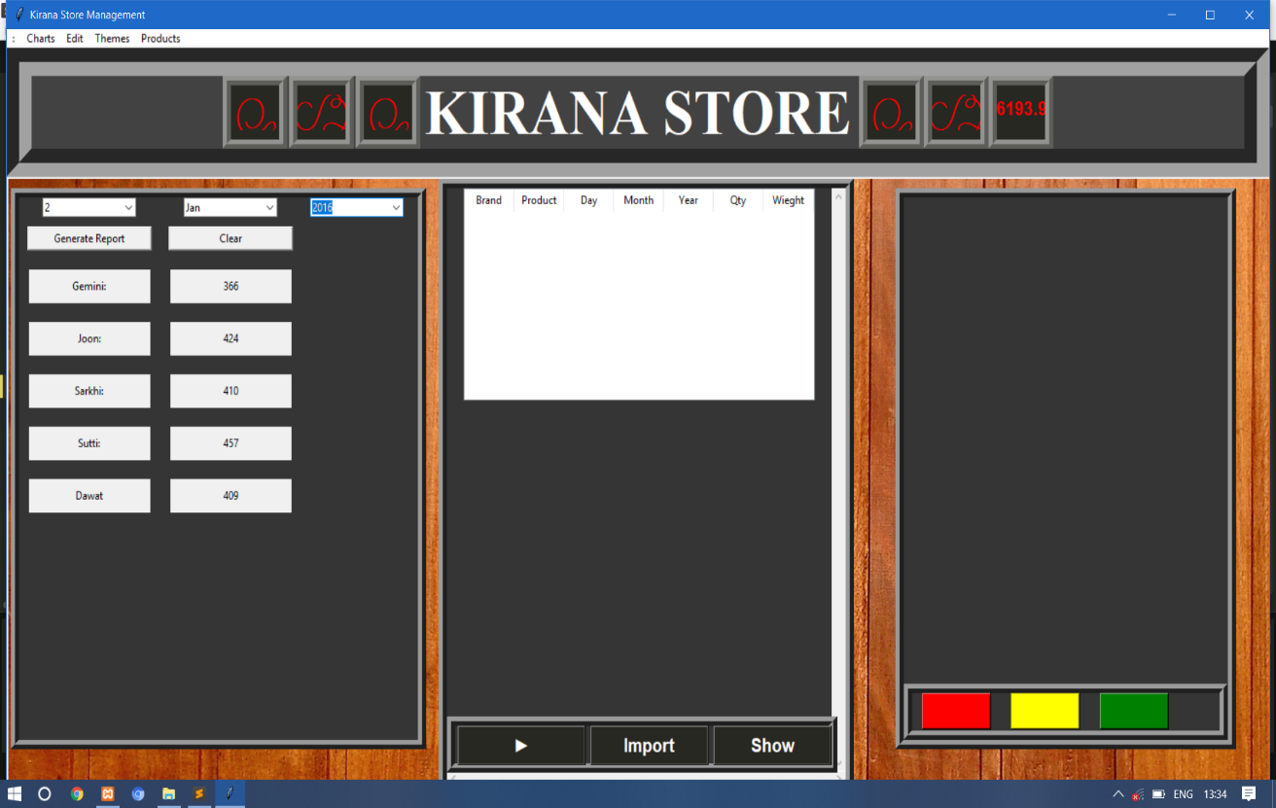

1. **Graphical report-**

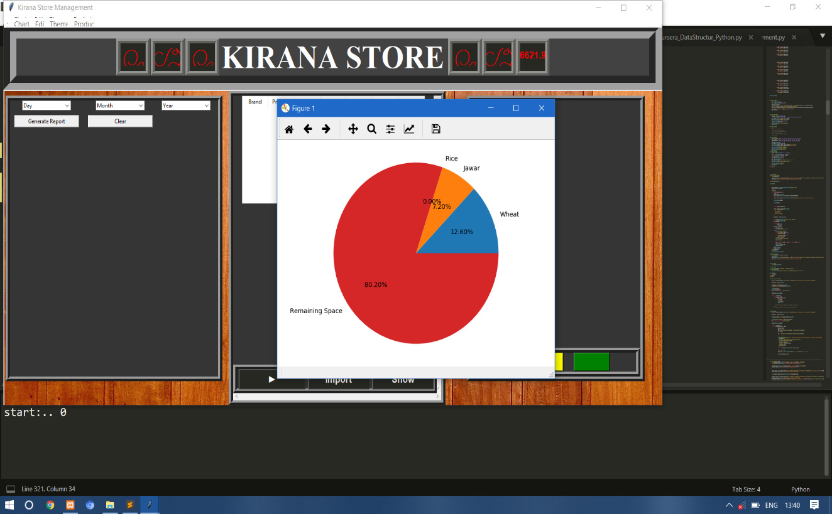

# 8. PERFORMANCE ANALYSIS

Existing system we requires many persons on the different departments like, to calculate the weight of stock, to write the detailed data about stock and many more manual work. The present system is based on manual technique and this project tends to automate the system so that maintaining the records of good stock, goods in and got out becomes easier than before. Existing system has many disadvantages like, Peoples tends to make error in manual data entry. Efficiency and accuracy is not expected. Time consuming and slow processing

In this proposed system identify the product with the help of image processing method . also it will check order given by the owner and provided total no of stock .All collected data stored into database. It helps to availability of data any time. It include Data analysis like, type of stock their weight its total and also rate. Features included Automated ordering of grocery stock and analysis of all data without using manual work. This system generates overall day to day report without any error automatically.

## Inventory Management software monitors inventory levels for optimal production and distribution of goods for wholesale or retail. Inventory management is the supervision of supply, storage and accessibility of items in order to ensure an adequate supply without excessive oversupply. Stock Management is often associated with understanding the different levels of demand on that inventory.

# APPLICATION

1. Platform for solving Manual issues.
2. User can help to store all details easily .
3. Under supervision of supply, storage and accessibility of items is possible.
4. Day to day report is generated.
5. Accuracy of data.
6. Used in grocery ware house.
7. Used in textile industry.
8. Used in small shops also.

# CONCLUSION:

Inventory management has to do with keeping accurate records of goods that are ready for shipment. This often means having enough stock of goods to the inventory totals as well as subtracting the most recent shipments of finished goods to buyers.Accurately maintaining figures on the finished goods inventory makes it possible to quickly convey information to sales personnel as to what is available and ready for shipment.

Inventory management is important for keeping costs down, while meeting regulation. Supply and demand is a delicate balance , and inventory management hopes to ensure that the balance is undisturbed.

We built a system where, Users will be able to capture their products automatically .All the data related to that product is stored in database for future reference also. Automatically day to day report is generated in different forms.it help to check daily stock in and stock out of product . And also remaining quantity of product in warehouse.

# 11. GUIDE TO ACCESS SYSTEM AND USER MANUAL

1. Connect to the network
2. Install the software
3. Get the system

**The Screenshots of project**

* 1. **Signup page-**

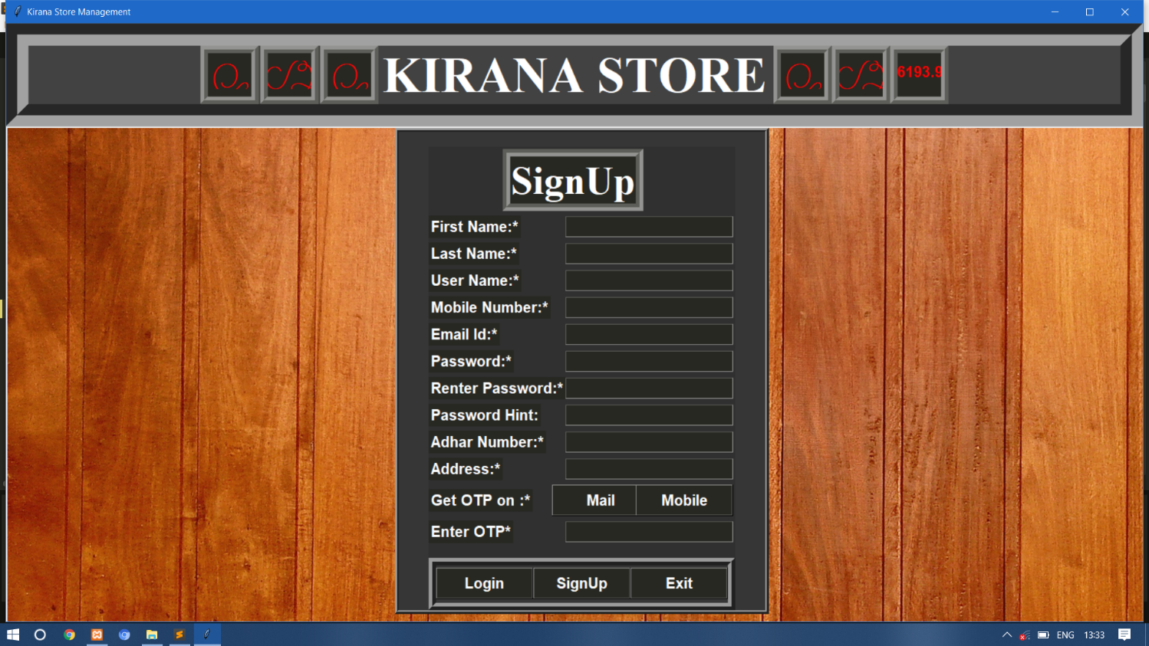

In this image we can see user have to give User name, Name, Password, contact no , email id this details. Using this details system will create his/her profile.

## Login page-

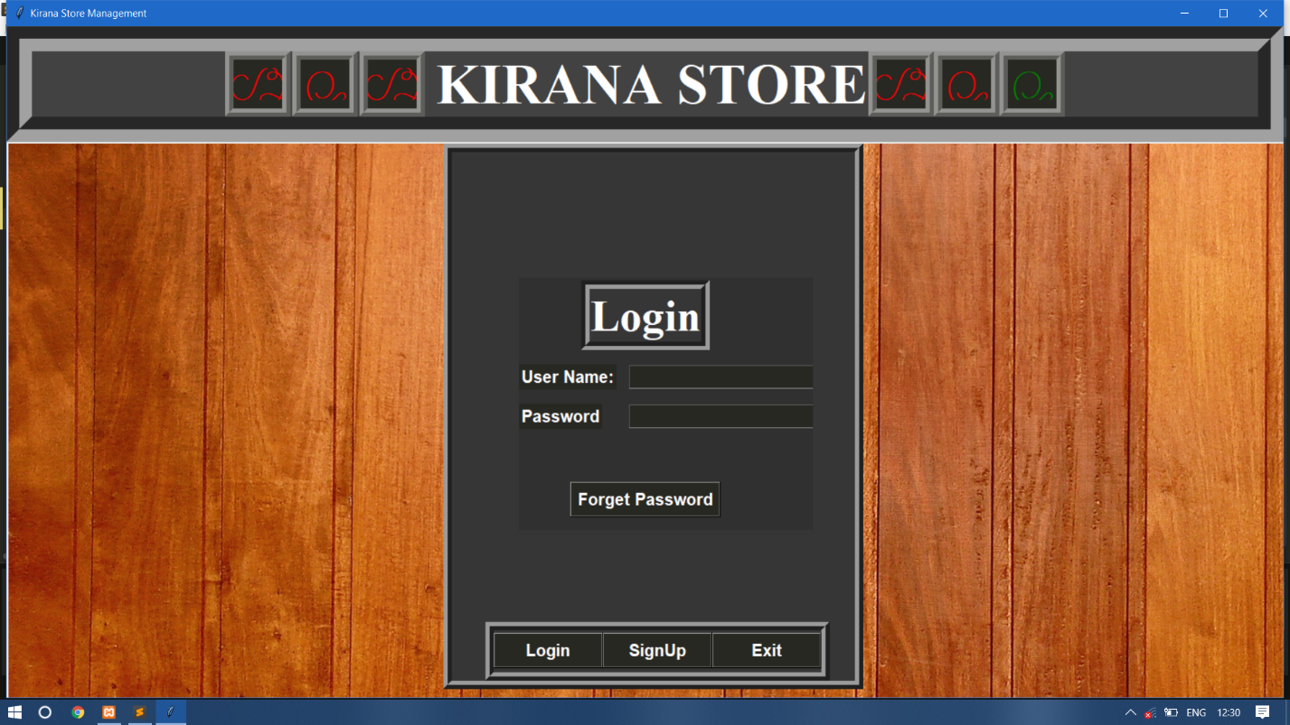

## Forgot password

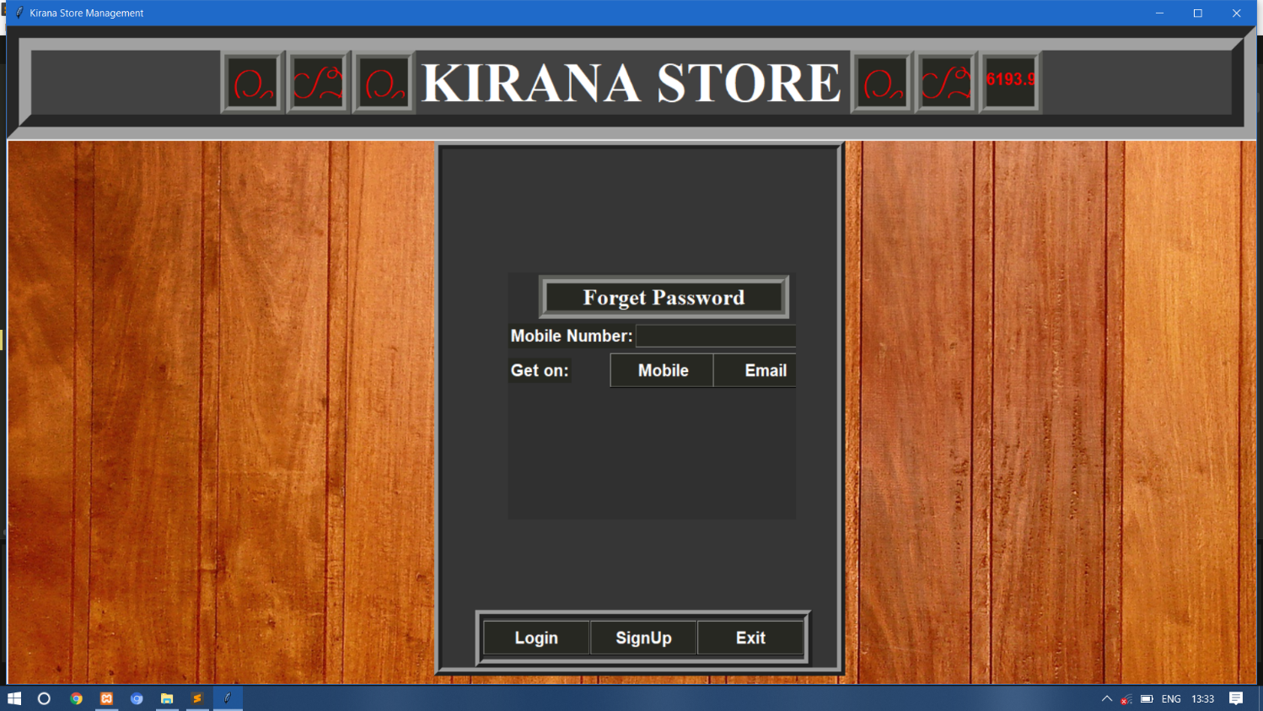

## Home

## 

## Availability of product

## 

* **Less availability of product-**

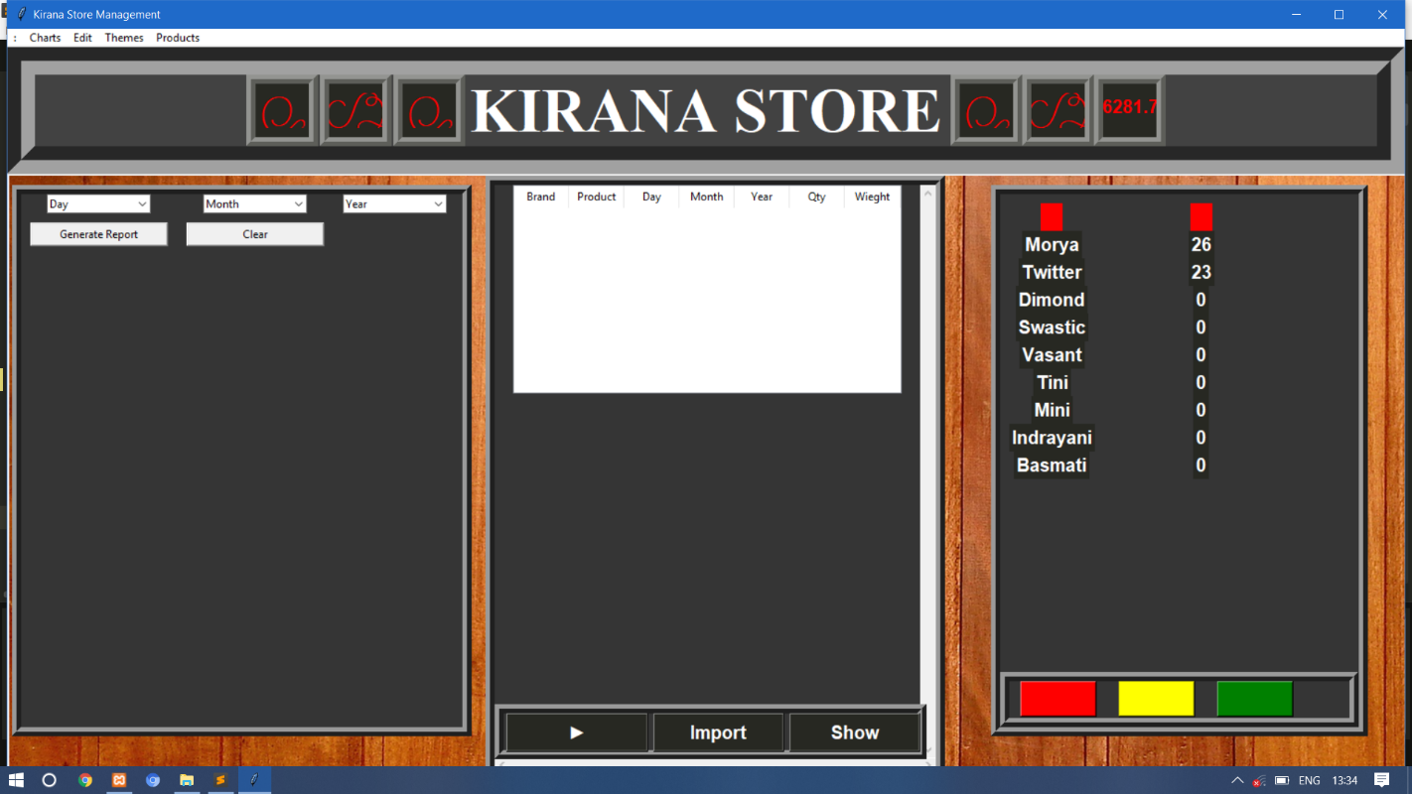

# Medium availability of product-

# 

# Full availability of product-

# 

# Report generation-

# 

## ETHICS

1. Make a copy of software for personal or commercial use.
2. Make a copy of software for a friend
3. Loan CDs of software to friends
4. Download pirated software from the internet
5. Distribute pirated software from the internet
6. Buy software with a single user license and then install it on multiple computers
7. Share a pirated copy of software
8. Install a pirated copy of software

# 13. REFERENCES

* P.G. Matsebatlela and K. Mpofu, “Inventory Management Framework to Minimize Supply and Demand Mismatch on a Manufacturing Organization”, International Federation of Automatic Control, Vol.3, No.48, Mar 2015, pp-260- 265.
* A literature review on inventory management in humanitarian supply chains -Burcu Balcik∗, Cem Deniz Caglar Bozkir, O. Erhun Kundakcioglu

Department of Industrial Engineering, Ozyegin University, 34794 Istanbul, Turkey

<https://www.researchgate.net/publication/311333429_A_literature_review_on_inventory_management_in_humanitarian_supply_chains>

# A literature review on models of inventory management under uncertainty -June 2015 [Business Systems & Economics](https://www.researchgate.net/journal/2029-8234_Business_Systems_Economics) 5(1) DOI: [10.13165/VSE-15-5-1-03](https://www.researchgate.net/deref/http%3A%2F%2Fdx.doi.org%2F10.13165%2FVSE-15-5-1-03)

# <https://www.researchgate.net/publication/279282285_A_literature_review_on_models_of_inventory_management_under_uncertainty>

* [**https://ieeexplore.ieee.org./document/8065839**](https://ieeexplore.ieee.org./document/8065839)
* [**https://www.researchgate.net/publication/237663955_Automation_Of_Inventory_Management_Process**](https://www.researchgate.net/publication/237663955_Automation_Of_Inventory_Management_Process)
* [**http://www.ijsrp.org/research-paper-0313/ijsrp-p15107.pdf**](http://www.ijsrp.org/research-paper-0313/ijsrp-p15107.pdf)